ZD,
REPORT OF JOINT INVESTIGATION VISIT BY NOSDRA, DPR, SPDC, RIVERS STATE MINISTRY OF ENVIRONMENT AND KPOGHOR/GIO COMMUNITY REPRESENTATIVES AT 28” NKPOGU – BOMU TRANS NIGER PIPE LINE (TNP) RIGHT OF WAY @ KPOGHOR/GIO IN TAI L.G.A OF RIVERS STATE.
INTRODUCTION
Acting on your directives on the SPDC request sent in on 8th September 2015, a Joint Investigation Visit (JIV) was conducted at the 28’’ Nkpogu – Bomu Trans Niger Pipeline (TNP) Right of Way at Kpoghor/Gio in Tai L.G.A of Rivers State on the 8th of September, 2015 at about 12:56Hrs. The investigation was completed successfully on the same day. This report provides details.
INCIDENT PARTICULARS: 2015_ 1481425
FACILITY AFFECTED: 28’’ NKPOKU-BOMU TNP ROW @ KPOGHOR/GIO IN RIVERS
STATE
DATE OF SPILL: 07/09/2015
DATE OF INSPECTION: 08/09/2015
CAUSE OF SPILL: SABOTAGE (See Fig.1a & b)
QUANTITY OF CRUDE OIL SPILLED: 0.04bbls
SPILL POINT COORDINATES: N 04^{O} 42’ 36.6’’
E 007^{O} 14’ 03.3”
NATURE OF IMPACT: Light (Source of Water supply affected)
INVESTIGATION TEAM:
- Koms Abam NOSDRA
- Gerard Onuigbo SPDC
- Nwadiashi Felix I. SPDC
- Chibuike Chibuzo DPR
- Igoloko-Abibo T. RIVERS STATE MINISTRY OF ENVIRONMENT
- Leyira Nnutam KPOGHOR COMMUNITY
- Patrick Ebenezer GIO COMMUNITY
OBSERVATIONS:
- The 28’’ TNP from Nkpoku to Bomu at this point is exposed and there were two previously repaired points with clamps, about 1M apart. Unknown persons removed the first clamp exposing the previous Hacksaw cut (25cm) which was at 1 O’clock position. (See Fig. 1a & b)
- The Spill occurred along SPDC ROW but a small Stream which is a source of water supply for farmers runs across the Pipe line. The impact may have affected the water. (See Fig. 2a & b)
IMPACTED AREA COORDINATES: 1. NOTHINGS: 4.71019 2. NOTHINGS: 4.71076
EASTHINGS: 7.23425 EASTHINGS: 7.23430
3. NOTHINGS: 4.71014 4. NOTHINGS: 4.71014
EASTHINGS: 7.23431 EASTHINGS: 7.23429
5. NOTHINGS: 4.71020 6. NOTHINGS: 4.71024
EASTHINGS: 7.23424 EASTHINGS: 7.23427
7. NOTHINGS: 4.71021
EASTHINGS: 7.23429

- No Pool of Free Phase Oil observed around the Spill Area at the time of investigation though the adjourning Vegetation had traces of Crude Oil stains. (See Fig. 3a & b)

FEED BACK:
- The Pipe Line at this point was neither buried nor protected from interference by third party.
- No surveillance point was seen close to the Spill Area.
RECOMMENDATIONS
- Surveillance of facilities need to be intensified to prevent future re-occurrence
- The affected area should be completely repaired and immediately cleaned up.
- The Pipeline should be “cased or casted with cement” for protection.
CONCLUSION
The JIV was successful. This report is subject to your steer and further directives.

Koms Abam
SES

_____________________________
9th September, 2015

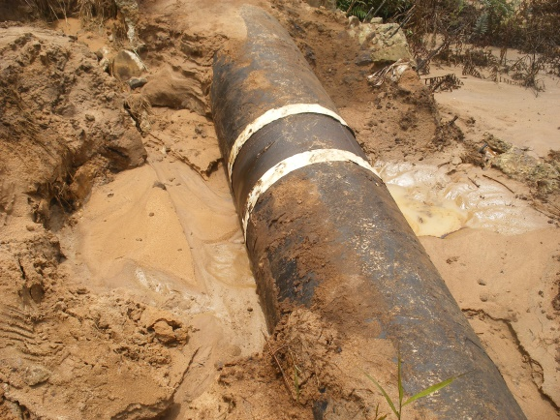 ` 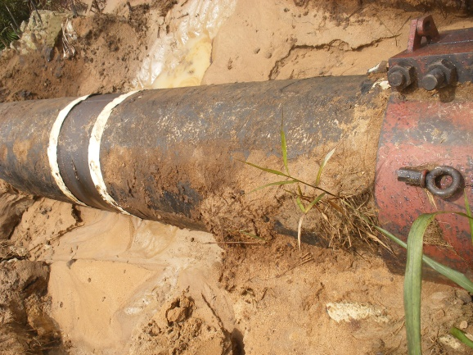
Fig. 1a Previous Clamp Missing Fig.1b Second Clamp still intact.

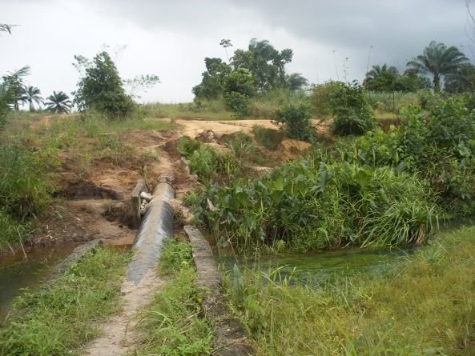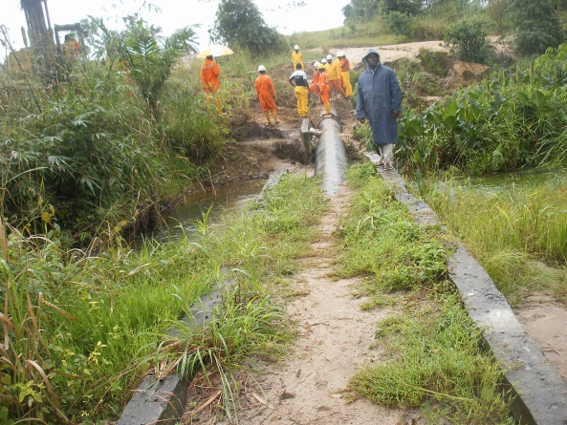
Fig. 2a ROW showing Water - Stream Fig. 2b Pipe Line exposed
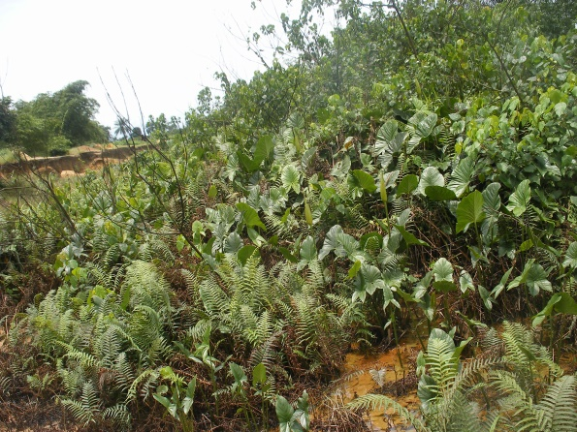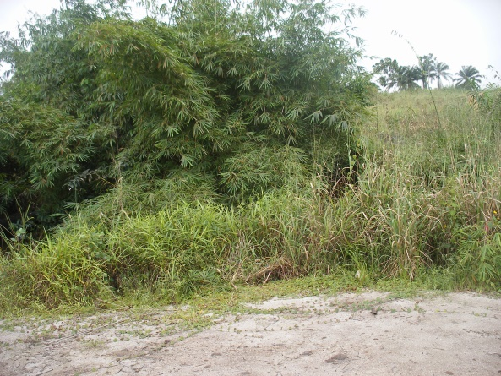
Fig. 3a Vegetation around Spill Area Fig. 3b Adjourning Environ along the Stream

